Ticket Booking System

1. 1List all events (basketball, volleyball, etc…

http://127.0.0.1:8000/api/event

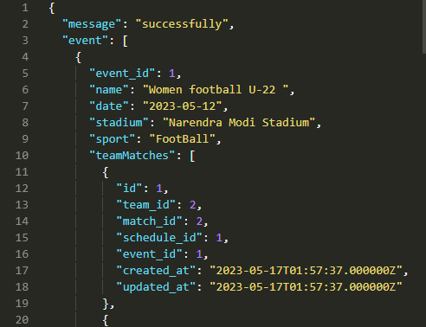

1. Search for an event

http://127.0.0.1:8000/api/event/search/Men Swimming

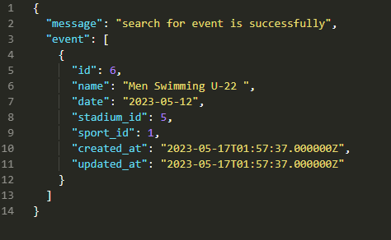

1. Get event details (teams, time, description, etc…)

<http://127.0.0.1:8000/api/event/6>

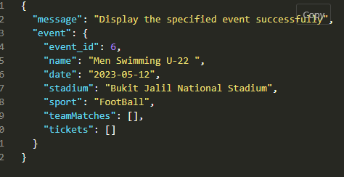

1. Buy a ticket

<http://127.0.0.1:8000/api/ticket>

{

"event_id": 2,

"zone_id":2

}

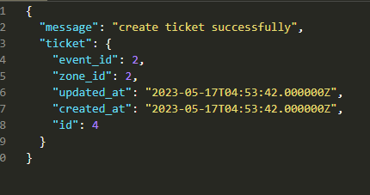

1. Create an event

<http://127.0.0.1:8000/api/event>

{

"name": "Men basketBall",

"date": "2023-05-18",

"stadium_id": 3,

"sport_id":2

}

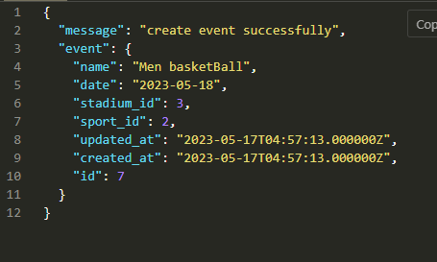

1. Delete an event

http://127.0.0.1:8000/api/event/2

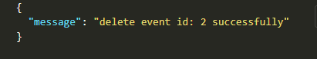

1. Edit an event

http://127.0.0.1:8000/api/event/5

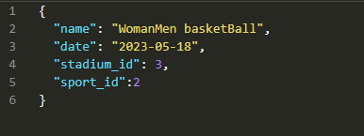

Result :

